**Hackathon day 3 marketplace Q commerce**

1 Firstly install sanity in previous hackathon2 project by command line

npm create sanity@latest -- --template clean --create-project "learning-sanity-project" --dataset production

answer default questions

npm run dev

localhost:3000/studio

**Api integration**

Create product.ts and categories.ts files in sanity/schemaTypes and add the code which is provided in the hackathon document

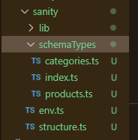

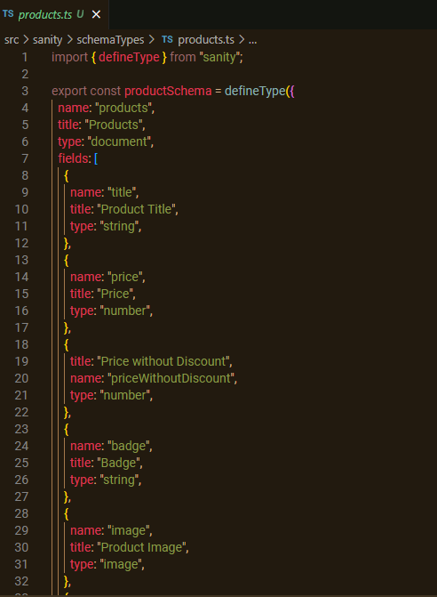

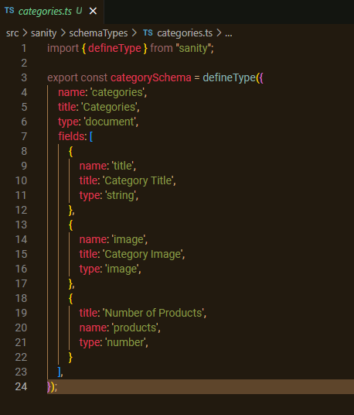

Then Importing Schemas in index.ts file.

**Data migration**

Make a folder of script inside script folder cleanup.mjs and migrate.mjs file and add the code available in document

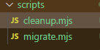

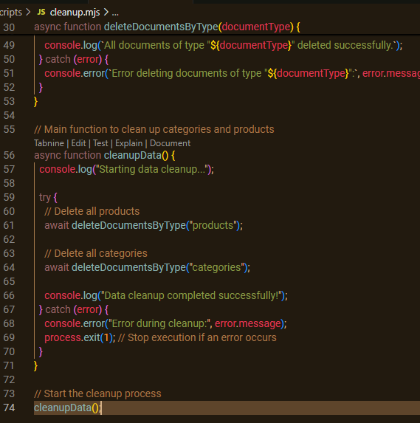

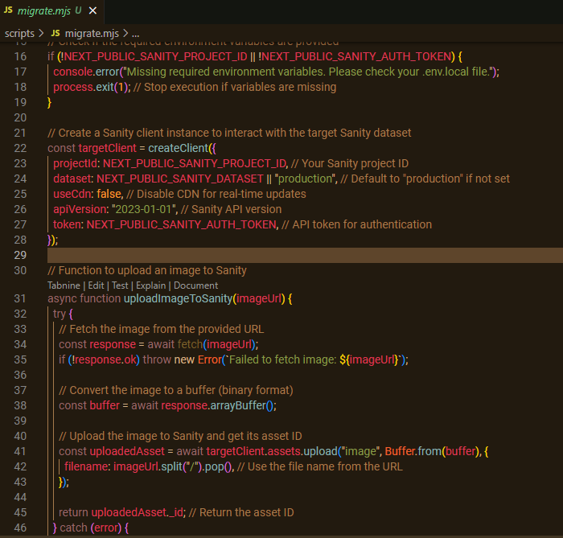

Environment variable setup by make a file of .env

Inside .env file adding project id, data set and token id (creatind token in sanity and get token id .

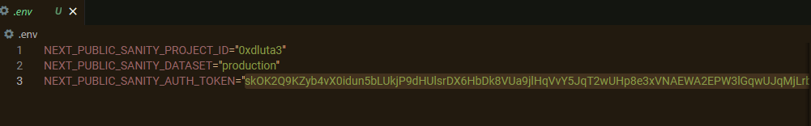

Now Open `package.json` file and add the following code inside of scripts: “migrate’: “node script/migrate.mjs”

Then run command npm install dotenv

And then npm run migrate.

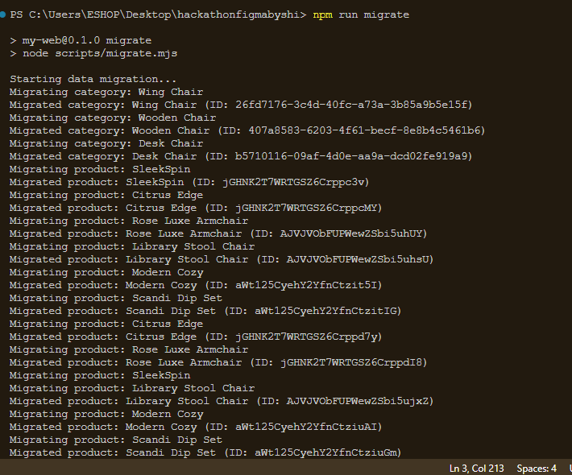

Here is preview

